Weyland Bulletin – June 2026
Millbrook: the planning application is in
Noah Fischer · 26 June 2026
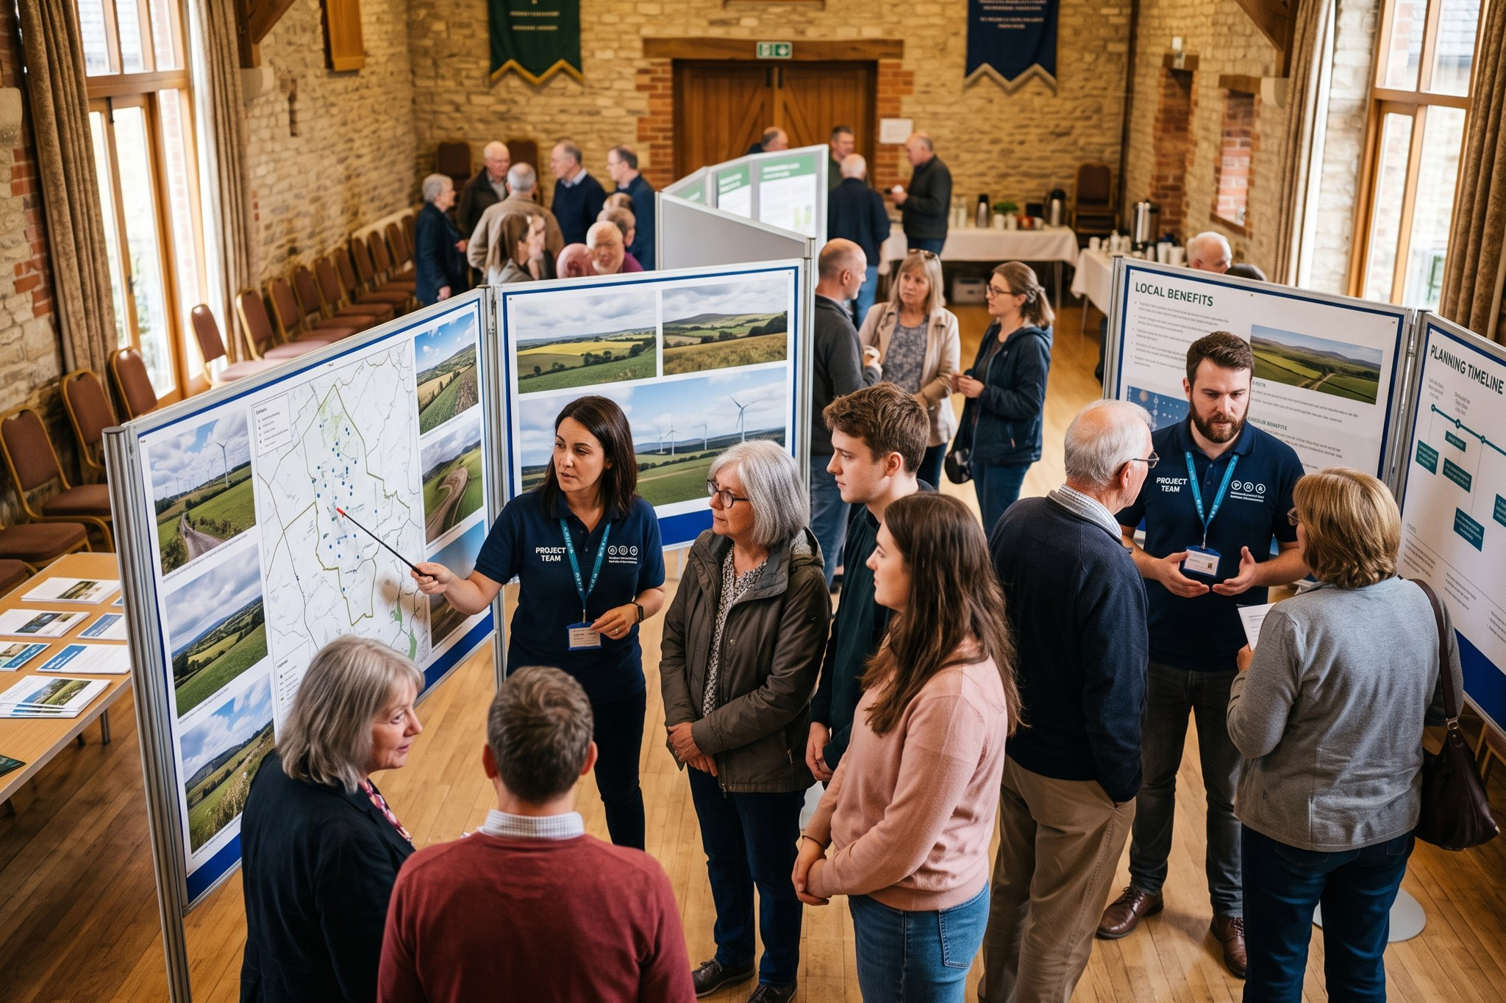

Millbrook: the planning application is in
On 18 June we submitted planning application MDC/2026/0412 to Millbrook District Council after two public consultations with more than 400 visitors.

Project update
Project | Status
Harrow Bay | 6 of 40 monopiles installed by the end of June
Kestrel Ridge | 13.8 GWh generated in May
Millbrook | Application MDC/2026/0412 under consideration
Fenwick | Land option signed on 30 April

People
Our Lunch & Learn on hydrogen with Isabel Ferreira had 120 listeners – the recording is on the intranet.
Weyland Bulletin is sent to 3,800 subscribers. Unsubscribe at any time.

